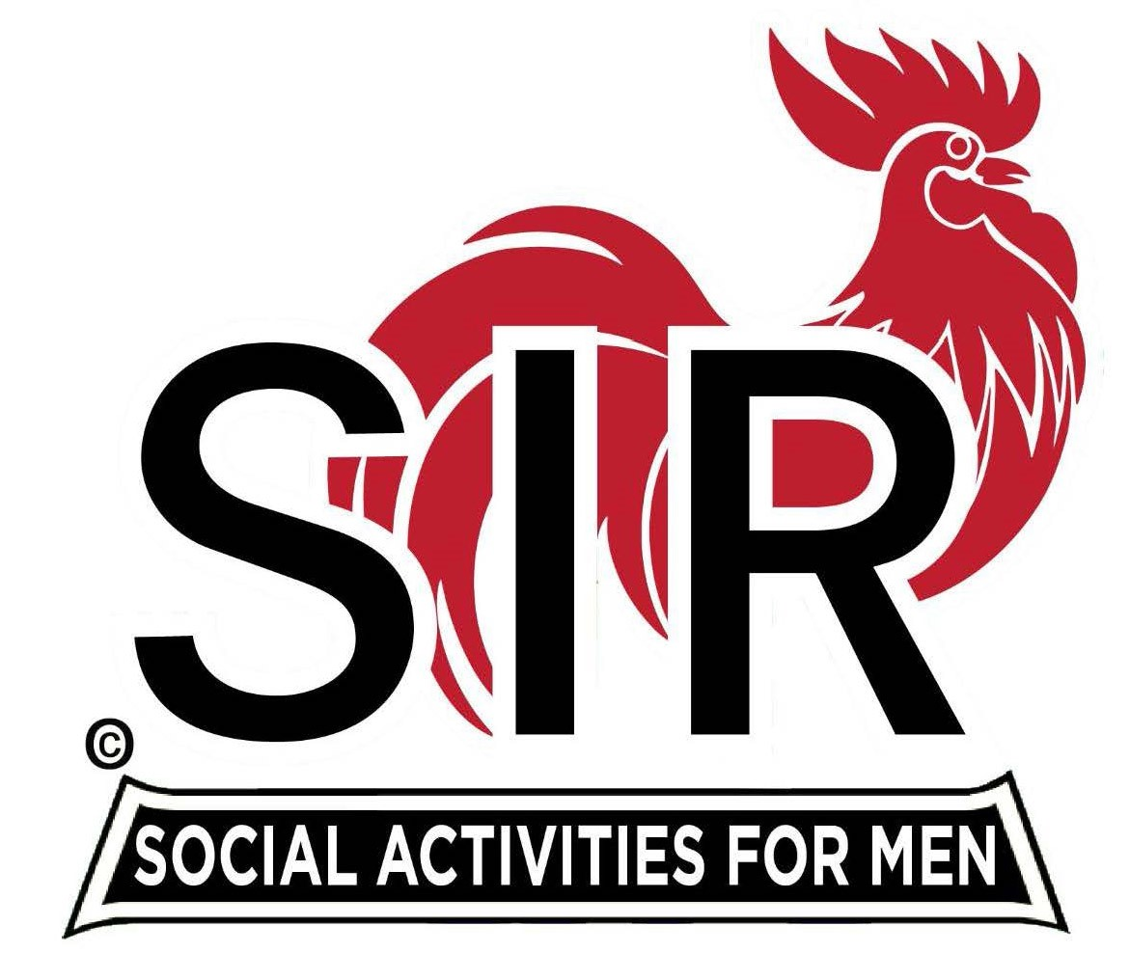

**Las Trampas Branch 116**

**BEC Meeting Agenda**

**March 17th, 2025 – 09:15 AM at Boundary Oak**

***The Mission of SIR is to enhance the lives of our members through fun activities, events and luncheons while making friends for life.***

|  |  |
| --- | --- |
| **09:15** | **Call to order**   * **Secretary, Dan Lawrence**    + **Confirm quorum and**   + **Approval of February, 17th 2025 BEC Meeting Minutes** |
| **09:20** | **Standing Reports**   * **Treasurer – Charlie Guthrie**   + **Treasury Report** * **Luncheon Count – 112** * **Big SIR Report – Paul Russell** * **We will be having the Spring Fling in May 21st at The Kensington in Walnut Creek this year. It is the sister retirement home to Byron Park where it was held last year it should be a good time and I think the cost will be just about $20.00. They will serve a buffet luncheon, have an Ice Breaker get together with music. Plus, a photo booth!!** * **Branch Advisory Council – Carlos Xavier Carlos is not here today due the cancellation of the Branch Advisory Council meeting this month.** * **Membership – Phill Goff** * **We will have 5 new members this month, with 7 resignations, for a net -2** * **RAMP Department Head Reports**   + **Recruitment – Brad Stribling**   + **Activity Coordinator – Mike Ward**   + **Member Relations – Sam Beret**   + **Publicity – Allan Farbman**     - **Plans**   + **Insurance Annual Resolution – Jeff Johnson** |
| **09:50** | **Little SIR Updates – Brad Stribling**   * **Speaker Info – Ms. Lindy Johnson** * **Birthday Boys – March 2025** |
| **09:55** | **Updates & New Business**   * **New Members – Paul Russell** * **Gary Summers – Sponsor Michael Barrington** * **Bruce Lewis – Sponsor Michael Barrington** * **Ron Wetter – Sponsor Alan Pope** * **Frank Mycroft – Sponsor Sam Beret** * **Guests**    + **Frank Colligan – Sponsor Jeff Johnson** |
| **10:15** | **Adjourn: Lunch Preparations** |
|  |  |